**Time Series Tech Document**

Excel Document

1. Changing the files into CSV format is a simpler format for plots and datasets to be read on
2. Ensuring that all missing data will not be factored into the output
3. Generate mean for data sets and aggregated all units to kW
4. Finalized datasets to be import into a plot

Python Script

1. You will first begin by downloading the most recent version of [Python](https://www.python.org/downloads/) 3.0 or higher.

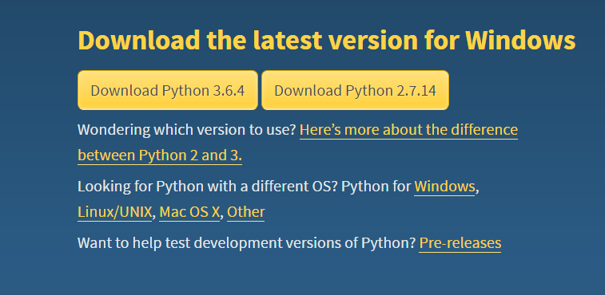

* Ensure to install Python in your PATH by checking the box
* Then proceed to follow with default options

1. Then you must download [PIP](https://bootstrap.pypa.io/get-pip.py), a Python tool for installing libraries.

* Follow the link and select all the text in that web browser
* Right click and save (in default folder) as get-pip.py

1. Open your downloads folder and go in your search bar

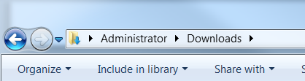

* From here, type in “cmd” in the search bar where it says Administrator 🡪 Downloads
* This will open up your command prompt editor where you will type “get-pip.py” and download pip for Python

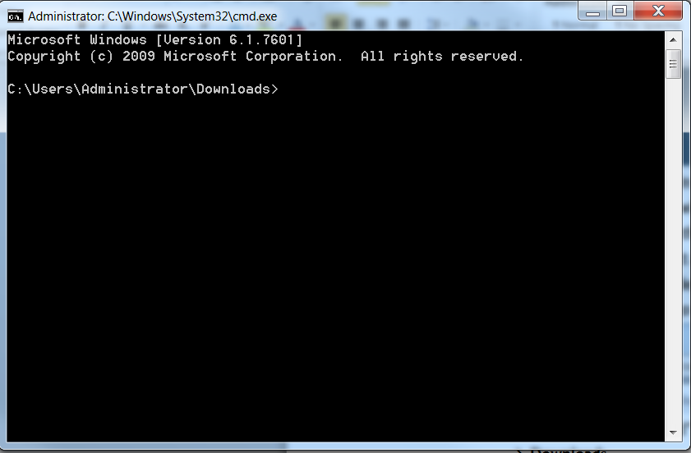

1. This follows a list of libraries that must be downloaded into Python using the command “pip install (followed by the library)”

* Pandas and Plotly

For example:



1. Once both libraries have been downloaded, run each Python script in idle to generate each time series analysis for the sites.

* Timeseries1, 2, and 3